**Setting up an Exchange 2013 mailbox on an iPhone or iPad**

*How do I set up an Exchange 2013 mailbox on an iPhone or iPad?*

Each version of Apple's iOS may vary slightly, but this guide will show you how to configure your mailbox using an iOS 11 device.

**Step 1**

Tap the **Settings** icon.

**Step 2**

Scroll down and press **Passwords & Accounts**.

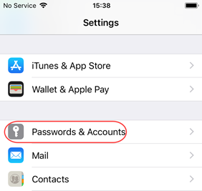

**Step 3**

Press **Add Account**.

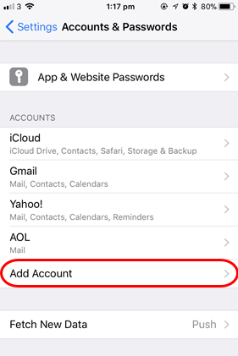

**Step 4**

Select **Exchange**.

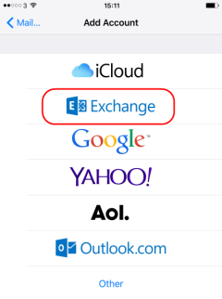

**Step 5**

Enter the following details, and click **Next**.

* **Email**: Enter your email address (for example *joeuser@oxfordasd,org*).
* **Description**: This is an optional description to help you identify the mail account in your device.

**Step 6**

Click **Configure Manually**

**Step 7**

Enter your mailbox password and click **Next**

**Step 8**

In the **Server** box enter *mail2.oxford.k12.pa.us*

**Step 9**

In the **Domain**, **Username**, and **Password** boxes enter the following information and press **Next**:

* **Domain:** OASD
* **Username**: Enter your network username which will is usually your first initial and then your last name.
* **Password**: This should already be filled in from the previous screen, if not enter your network password.

**Step 10**

Your device will test your connection to your mailbox. When the test is complete, you will be prompted to choose which items you wish to sync with your device.

**Step 11**

Click **Save** at the top right of the screen to store your mailbox settings.